**QUESTION 1** (11 marks)

Question 1relates to the pedigree shown below. This shows the inheritance of a rare (but not serious) blood disorder through four generations.

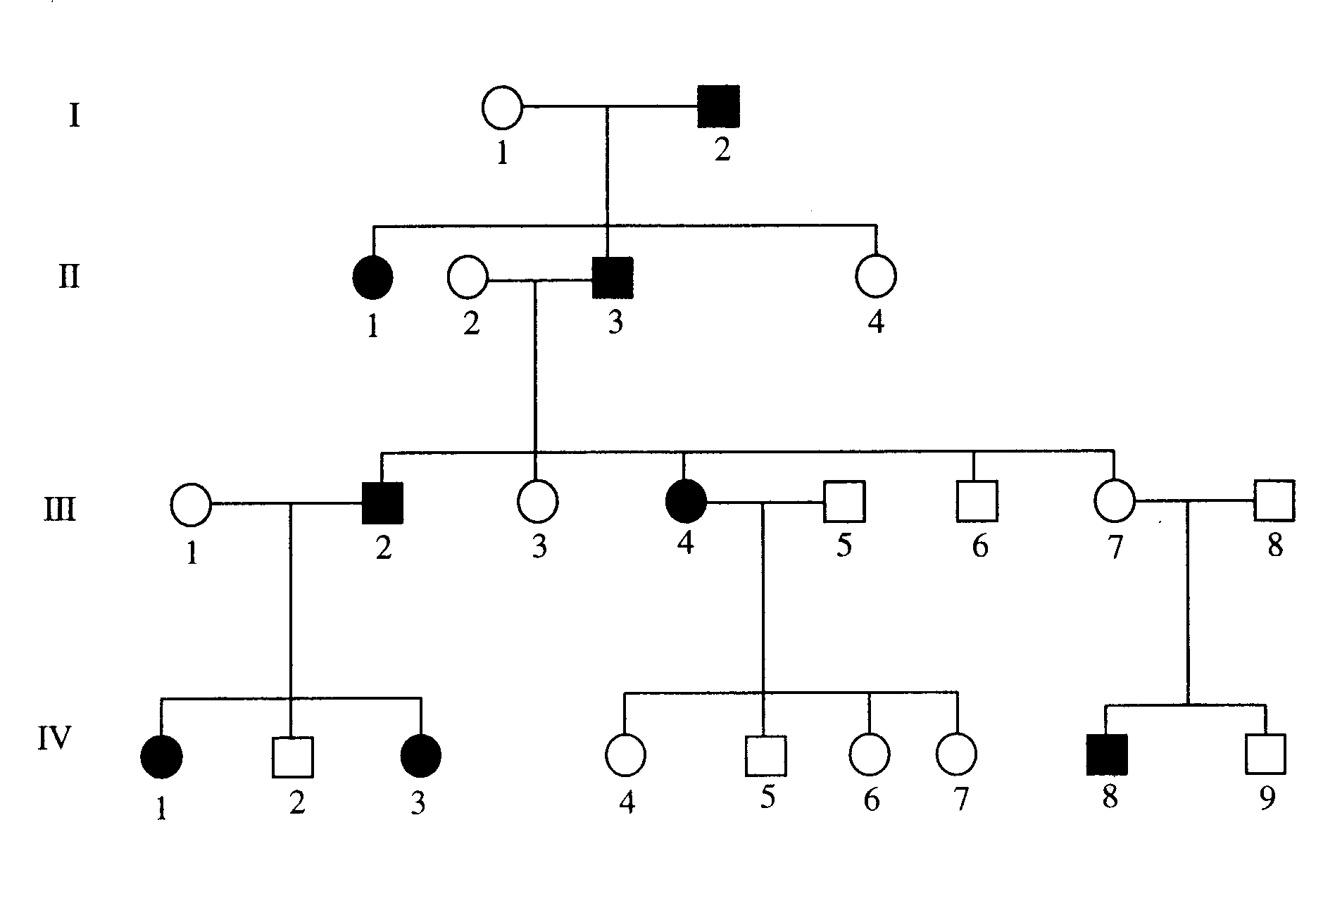

1. Is the disorder inherited as a dominant or recessive trait? Explain.

(2)

1. Using **TWO** distinct examples, explain why the disorder cannot be inherited as a sex-linked trait?

(2)

1. If Individuals III 4 and III 5 have another baby (assuming that III 5 is heterozygous).
   1. What is the probability that it will have the blood disorder?

(1)

* 1. What is the probability that it will be a male and NOT have the disorder?

(1)

1. Recent evidence suggests that individuals with blood type A will not show the phenotype for the disorder.
   1. What does the term phenotype mean?

(1)

* 1. Individuals III 4 and III 5 are blood types O and AB respectively. What are the possible genotypes of their offspring?

(2)

* 1. Will any of the offspring display the blood disorder? Explain.

(2)

**QUESTION 2**

Question 2 relates to the pedigree shown below. This shows the inheritance of Friedreich’s ataxia, a rare condition affecting 1 in 50 000 people. The onset of Friedreich’s ataxia is usually between the ages of five to fifteen. Friedreich’s ataxia results in the degeneration of the nerves in the spinal cord and cerebellum, leading to the loss of the coordination of limb movements, slurred speech and muscle wasting in the limbs.

I

**1**

**2**

**II**

**4**

**5**

**1**

**2**

**3**

III

**3**

**2**

**1**

1. What is the mode of inheritance for this condition?

|  |
| --- |
|  |

(2 marks)

1. Outline the evidence in the pedigree that provides **definite** support for your answer in part (a) above.

|  |
| --- |
|  |
|  |
|  |
|  |

(2 marks)

1. If individuals II4 and II5 have another baby.
   1. What is the probability that the baby will have Friedreich’s ataxia?

|  |
| --- |
|  |

(1 mark)

* 1. What is the probability that it will be a male and NOT have this disorder?

|  |
| --- |
|  |
|  |

(1 mark)

1. Individuals who inherit the Duchenne form of muscular dystrophy also experience muscle wasting as one consequence of this disorder. Compare the mode of inheritance for this disorder to Friedreich’s ataxia and describe the life span for an individual infected with muscular dystrophy.

|  |
| --- |
|  |
|  |
|  |
|  |
|  |

(2 marks)

QUESTION 3

Refer to the following pedigree for parts (a) – (f). In each generation (I, II, III) individuals are identified by numbering from the left to right across the pedigree (I 1, I 2, I 3, etc).

**I**

**II**

**III**

1. State whether this condition is most likely to be transmitted on an autosomal chromosome or a sex chromosome.

___________________________________________________________________________

(1 mark)

1. Explain how you arrived at your answer to part (a).

___________________________________________________________________________

______________________________________________________________________________________________________________________________________________________

(1 mark)

1. Is the trait dominant?

___________________________________________________________________________

(1 mark)

1. Using ‘A’ to indicate dominant and ‘a’ to denote recessive alleles, what is the genotype of individual III 4?

___________________________________________________________________________

(1 mark)

1. II 4 and II 5 are expecting another child. What is the probability that their fourth child will have the affected phenotype? Show your working.

___________________________________________________________________________

______________________________________________________________________________________________________________________________________________________

______________________________________________________________________________________________________________________________________________________

(2 marks)

1. From your responses in (a) to (c), give a genetic disorder that would have the same pattern of inheritance as the pedigree above. Also describe how the disorder would be treated?

____________________________________________________________________________________________________________________________________________________________________________________________________________________________________________________________________________________________________________

______________________________________________________________________________________________________________________________________________________

(3 marks)

**QUESTION 4**

The following pedigree shows the inheritance of Huntington’s disease over four generations. In each generation (I, II, III etc) individuals are identified by numbering from the left to right across the pedigree (I.1, II.2, III.3 etc).

**I**

**II**

**III**

**IV**

1. Individual II.4 is the first individual in this pedigree to be affected by Huntington’s disease. What must have happened to cause this condition?

______________________________________________________________________________________________________________________________________________________________________________________________________

(1 mark)

1. From the evidence in the pedigree, state whether this condition is most likely to be transmitted on an autosomal chromosome or a sex chromosome.

____________________________________________________________________________________________________________________________________

(1 mark)

1. Explain how you arrived at your answer to (b).

__________________________________________________________________

____________________________________________________________________________________________________________________________________

(2 marks)

1. Indicate whether the allele for Huntington’s is dominant or recessive.

__________________________________________________________________

(1 mark)

1. Using ‘A’ to indicate dominant and ‘a’ to denote recessive alleles, what is the genotype of individual III .3?

__________________________________________________________________

(1 mark)

1. III.4 and III.5 are expecting another child. What is the probability that their fourth child will have the affected phenotype? Show your working.

__________________________________________________________________

__________________________________________________________________

__________________________________________________________________

__________________________________________________________________

__________________________________________________________________

(2 marks)

1. Describe **TWO** symptoms of an individual suffering from Huntington’s.

____________________________________________________________________________________________________________________________________

__________________________________________________________________

__________________________________________________________________

(2 marks)